RT-KVM Research Report

Lenovo Cloud Server Team
Sang Li-Peng

Contents
Realtime Definition 3
Realtime Requirement 3
Latency Source 4
The PREEMPT_RT kernel 4
Realtime Virtualization 4
Realtime virtualization problems and solution: 4
Realtime Virtualization Reference Achitecture: 6
The PREEMPT_RT kernel configuration 6
1. Getting the Sources 6
2. Patching the Sources 6
3. Configuring the Kernel 6
The Benchmark Cyclictest 6
Experimentation 7
Test condition 7
Test Cases 7
1. The whole system 7
2. How to create the graphic test result 8
3. The Isolation system with RT partitions on CPU 0 - 5 11
4. VM on the whole system 12
5. VM on the Isolation system with RT partitions on CPU 0 – 5 13
Reference 16

Realtime Definition
Realtime is about determinism, not speed. Speed is useful, but guaranteeing this kind of latency bound almost always results in lower throughput.
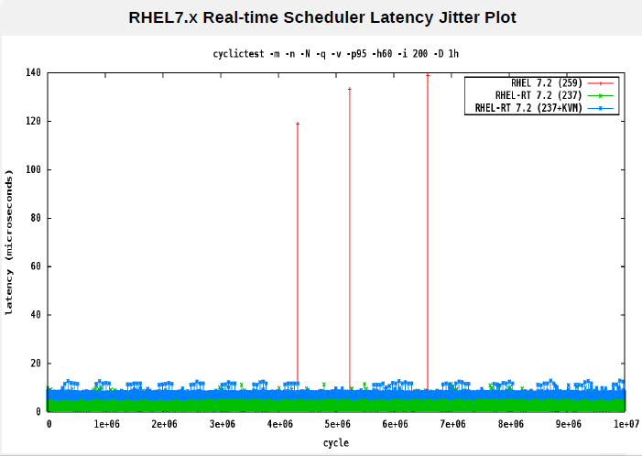

Realtime Requirement
Realtime workloads are those where missing deadlines is bad: it results in voice breaking up in telecommunications equipment, missed opportunities in stock trading, and exploding rockets in vehicle control and avionics. These applications can have thousands of deadlines a second; the maximum allowed response time can be as low as a few dozen microseconds, and it has to be met 99.999% of the time, if not ... just always.
Target Field:
- Communication systems(media streaming & switching, etc.)
- Trading systems(stocks, goods, etc.)
- Control systems(industry, healthcare, transportation, etc.)

Latency Source
Nearly every latency source in a system comes from the kernel
- A driver could disable interrupts and prevent high-priority programs from being scheduled.
- Spinlocks are another cause of latency in a non-realtime kernel, because Linux cannot schedule() while holding a spinlock.

The PREEMPT_RT kernel

These issues can be controlled by running a kernel built with PREEMPT_RT, the realtime kernel patch set. A PREEMPT_RT kernel tries hard to make every part of the Linux kernel preemptible, except for short sections of code. The PREEMPT_RT patch, while still large, has to do much less than it used to. The main three things it does are: turn non-raw spinlocks into mutexes with priority inheritance, actually run all interrupt handlers in threads so that realtime tasks can preempt them, and an RCU implementation that supports preemption. The detail are as:
- Making in-kernel locking-primitives (using spinlocks) preemptible though reimplementation with rtmutexes:
- Critical sections protected by i.e. spinlock_t and rwlock_t are now preemptible. The creation of non-preemptible sections (in kernel) is still possible with raw_spinlock_t (same APIs like spinlock_t)
- Implementing priority inheritance for in-kernel mutexes, spinlocks and rw_semaphores. For more information on priority inversion and priority inheritance
- Converting interrupt handlers into preemptible kernel threads: The RT-Preempt patch treats soft interrupt handlers in kernel thread context, which is represented by a task_struct like a common userspace process. However it is also possible to register an IRQ in kernel context.
- Converting the old Linux timer API into separate infrastructures for high resolution kernel timers plus one for timeouts, leading to userspace POSIX timers with high resolution.

Realtime Virtualization

Realtime virtualization problems and solution:
- The priority of the tasks in the virtual machine (VM) is not visible to the host and neither are lock holders inside a guest. This limits the scheduler's flexibility and prevents priority inheritance, so all of the virtual CPUs (VCPUs) have to be placed at a very high priority.
- Only ksoftirqd has a higher priority, since it delivers interrupts to the virtual CPUs.
- In order to avoid starving the host, systems have to be partitioned between CPUs running system tasks and isolated CPUs (marked with the isolcpus and nohz_full kernel command-line arguments) running realtime guests.
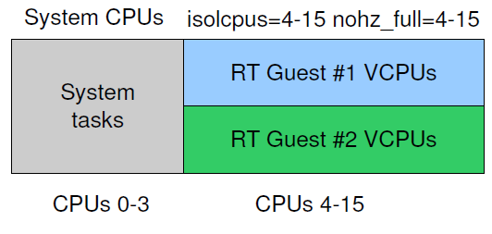
- The guest has to be partitioned in the same way between realtime VCPUs and those that run generic tasks. The latter could occasionally cause exits to the host user space, which are potentially long and—much like SMIs on bare metal—prevent the guest scheduler from running.
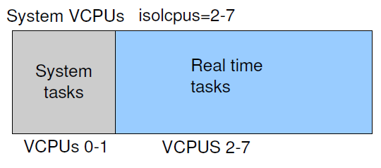

Realtime Virtualization Reference Achitecture:
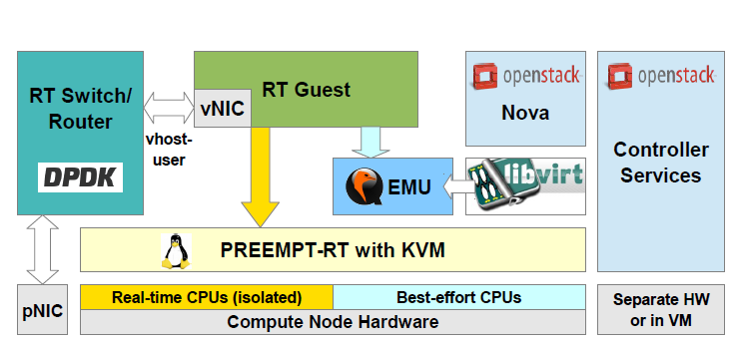

The PREEMPT_RT kernel configuration
- Getting the Sources

# wget ftp://ftp.kernel.org/pub/linux/kernel/v4.x/linux-4.4.7.tar.bz2
# wget http://www.kernel.org/pub/linux/kernel/projects/rt/patch-4.4.7-rt16.bz2

- Patching the Sources

# tar xfj linux-4.4.7.tar.bz2
# cd linux-4.4.7
# bzcat ../patch-4.4.7-rt16.bz2 | patch -p1

- Configuring the Kernel

- Enable CONFIG_PREEMPT_RT
- Activated the High-Resolution-Timer Option (Attention, the
- amount of supported platforms by the HR timer is still very limited. Right now the option is only supported on x86 systems, PowerPC and ARM Support are however in queue.)
- Disabled all Power Management Options like ACPI or APM.

The Benchmark Cyclictest
Cyclictest results are the most frequently cited real-time Linux metric. The core concept of Cyclictest is very simple. However the test options are very extensive.
Get the latest sources from the git repository, do a git clone git://git.kernel.org/pub/scm/utils/rt-tests/rt-tests.git or fetch a released tarball from the archive, untar into a directory of your choice and run make in the source directory. If you want to cross compile, just run make CROSS_COMPILE=<your-compiler-prefix> (for example make CROSS_COMPILE=arm-v4t-linux-gnueabi-).
You can run the resulting binary from there or install it.
lgs@f11#> git clone git://git.kernel.org/pub/scm/utils/rt-tests/rt-tests.git
lgs@f11#> cd rt-tests
lgs@f11#> make all
lgs@f11#> cp ./cyclictest /usr/bin/
lgs@f11#> cyclictest --help

Experimentation

Test condition

Hardware:
CPU: 8 Cores; Intel(R) Core(TM) i7-4790 CPU @ 3.60GHz
MemTotal: 8164316KB

Linux:
CentOS 7.0
Linux kernel 4.4.7
Linux kernel 4.4.7-rt16

Command:
cyclictest -t1 -p 80 -n -i 10000 -l 10000
partrt

Test Cases
- The whole system

Run the cyclictest on the Linux kernel 4.4.7 and kernel 4.4.7-rt16 without RT

Partition.

From the test result, we observe that the Max latency on kernel 4.4.7-rt16 is

remarkably improved.

Test Case: The whole system

Linux kernel 4.4.7
===================
[root@host]# cyclictest -t1 -p 80 -n -i 10000 -l 10000
/dev/cpu_dma_latency set to 0us
policy: fifo: loadavg: 0.31 0.55 0.27 1/417 4156

T: 0 ( 4138) P:80 I:10000 C: 10000 Min: 1 Act: 1 Avg: 10 Max: 60

Linux kernel 4.4.7-rt16
========================
[root@host]# cyclictest -t1 -p 80 -n -i 10000 -l 10000
/dev/cpu_dma_latency set to 0us
policy: fifo: loadavg: 0.28 0.44 0.23 1/426 4931

T: 0 ( 4214) P:80 I:10000 C: 10000 Min: 1 Act: 2 Avg: 8 Max: 17

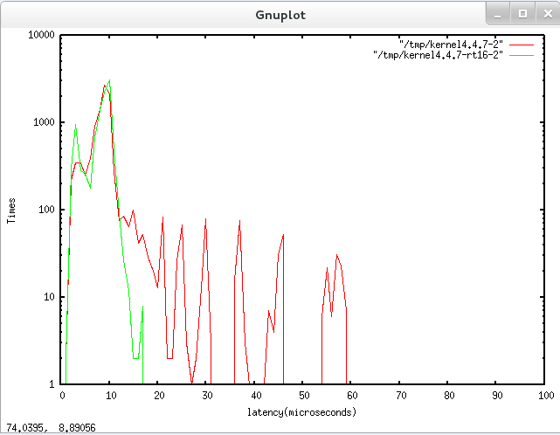

- How to create the graphic test result

This case shows how to create the graphic test result.

How to create the graphic test result
[root@host]# cyclictest -p 90 -m -c 0 -i 200 -n -h 100 -q -i 10000 -l 10000 | tee /tmp/rt-version
# /dev/cpu_dma_latency set to 0us
# Histogram
000000 000000
000001 000324
000002 001328
000003 000527
000004 000320
000005 000275
000006 000595
000007 001211
000008 001792
000009 002186
000010 000680
000011 000300
000012 000203
000013 000101
000014 000059
000015 000034
000016 000027
000017 000009
000018 000012
000019 000012
000020 000004
000021 000000
000022 000000
000023 000000
000024 000000
000025 000000
000026 000000
000027 000000
000028 000000
000029 000000
000030 000000
000031 000000
000032 000000
000033 000000
000034 000000
000035 000000
000036 000000
000037 000000
000038 000000
000039 000000
000040 000000
000041 000000
000042 000000
000043 000001
000044 000000
000045 000000
000046 000000
000047 000000
000048 000000
000049 000000
000050 000000
000051 000000
000052 000000
000053 000000
000054 000000
000055 000000
000056 000000
000057 000000
000058 000000
000059 000000
000060 000000
000061 000000
000062 000000
000063 000000
000064 000000
000065 000000
000066 000000
000067 000000
000068 000000
000069 000000
000070 000000
000071 000000
000072 000000
000073 000000
000074 000000
000075 000000
000076 000000
000077 000000
000078 000000
000079 000000
000080 000000
000081 000000
000082 000000
000083 000000
000084 000000
000085 000000
000086 000000
000087 000000
000088 000000
000089 000000
000090 000000
000091 000000
000092 000000
000093 000000
000094 000000
000095 000000
000096 000000
000097 000000
000098 000000
000099 000000
# Total: 000010000
# Min Latencies: 00001
# Avg Latencies: 00006
# Max Latencies: 00043
# Histogram Overflows: 00000
# Histogram Overflow at cycle number:
# Thread 0:

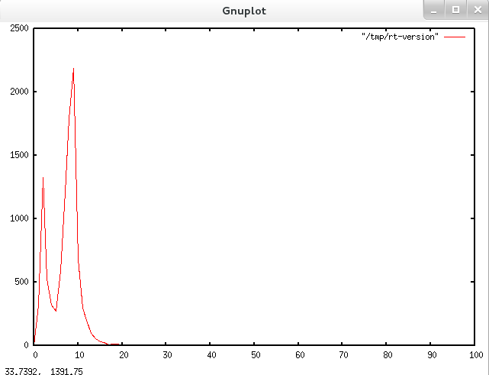

- The Isolation system with RT partitions on CPU 0 - 5
Create the RT partitions on CPU 0-5 and run the cyclictest on the RT partition.
From the result, the Max latency is remarkably improved regardless on the kernel 4.4.7 or kernel 4.4.7-rt16.
It should be noted that the Max latency on kernel 4.4.7-rt16 isn’t better than kernel 4.4.7, even that the Max latency on kernel 4.4.7 is better.
We need to investigate the root course of it.

Test Case: The Isolation system with RT partitions on CPU 0 - 5:

[root@host]# partrt create 0x3f
System was successfylly divided into following partitions:
Isolated CPUs (rt):0-5
Non-isolated CPUS (nrt):6-7
[root@sanglp ~]# partrt list
Name:nrt CPUs: 6-7
Name:rt CPUs: 0-5

Linux kernel 4.4.7
===================
[root@host]# partrt run -c 0x8 rt cyclictest -t1 -p 80 -n -i 10000 -l 10000
# /dev/cpu_dma_latency set to 0us
policy: fifo: loadavg: 0.00 0.07 0.13 1/417 6519

T: 0 ( 6510) P:80 I:10000 C: 10000 Min: 1 Act: 1 Avg: 1 Max: 4

Linux kernel 4.4.7-rt16
=======================
[root@host]# partrt run -c 0x8 rt cyclictest -t1 -p 80 -n -i 10000 -l 10000
# /dev/cpu_dma_latency set to 0us
policy: fifo: loadavg: 0.10 0.28 0.14 1/327 3250

T: 0 ( 3234) P:80 I:10000 C: 10000 Min: 1 Act: 2 Avg: 1 Max: 12

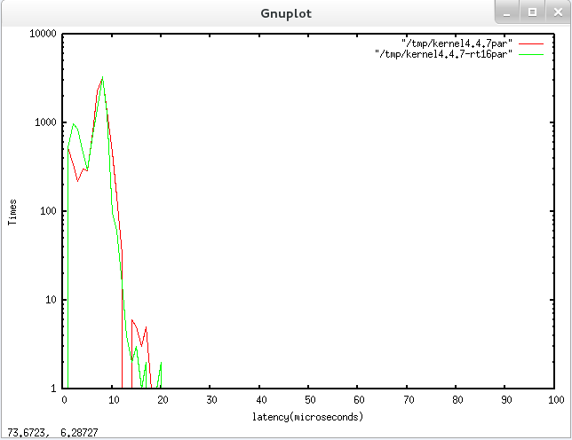

- VM on the whole system

Run the cyclictest on the guest kernel, the host is the whole system kernel4.4.7 without RT partition. The guest kernel is respectively kernel 4.4.7 or kernel 4.4.7-rt16.

From the test result, the Max latency on guest kernel is worse than on the host system. And the Max latency on the guest kernel 4.4.7 is similar with on the kernel 4.4.7-rt16.

Test Case: VM on the whole system

Host kernel4.4.7, Client kernel 4.4.7
======================================
[root@vm]# ./cyclictest -t1 -p 80 -n -i 10000 -l 10000
# /dev/cpu_dma_latency set to 0us
policy: fifo: loadavg: 0.08 0.13 0.12 1/402 15463

T: 0 (15454) P:80 I:10000 C: 10000 Min: 9 Act: 118 Avg: 93 Max: 202

Host kernel4.4.7, Client kernel 4.4.7-rt16
==========================================
[root@vm]# ./cyclictest -t1 -p 80 -n -i 10000 -l 10000
# /dev/cpu_dma_latency set to 0us
policy: fifo: loadavg: 0.09 0.23 0.30 1/423 5158

T: 0 ( 5149) P:80 I:10000 C: 10000 Min: 8 Act: 20 Avg: 66 Max: 142

- VM on the Isolation system with RT partitions on CPU 0 – 5

Step1: Ensure the guest kernel run on the RT partitions on CPU0–5, then run the cyclictest on the guest kernel.

From the test result, the Max latency is very bad regardless the guest kernel 4.4.7 or guest kernel 4.4.7-rt16. The test result shows it doesn’t work totally.

Step2: Undo the RT partitions on the host system without reboot, then then run the cyclictest on the guest kernel.

From the test result, the Max latency is remarkably improved than on the RT partitions regardless the guest kernel 4.4.7 or guest kernel 4.4.7-rt16.

Step3: Create the RT partitions on the guest kernel, then then run the cyclictest on the guest kernel.

From the test result, the Max latency isn’t remarkably improved than on the guest kernel without RT partitions regardless the guest kernel 4.4.7 or guest kernel 4.4.7-rt16.

Test Case: VM on the Isolation system with RT partitions on CPU 0 - 5:

[root@host]# partrt list
Name:nrt CPUs: 6-7
Name:rt CPUs: 0-5

[root@host]# ps -eLo ruser,pid,ppid,lwp,psr,args | grep qemu | grep -v grep
root 5948 3941 5948 6 qemu-system-x86_64 centos7.img -smp 6 -m 2048 -net nic -net tap,ifname=tap1,script=./qemu-ifup
root 5948 3941 5957 7 qemu-system-x86_64 centos7.img -smp 6 -m 2048 -net nic -net tap,ifname=tap1,script=./qemu-ifup
root 5948 3941 5958 6 qemu-system-x86_64 centos7.img -smp 6 -m 2048 -net nic -net tap,ifname=tap1,script=./qemu-ifup
root 5948 3941 5959 7 qemu-system-x86_64 centos7.img -smp 6 -m 2048 -net nic -net tap,ifname=tap1,script=./qemu-ifup
root 5948 3941 5960 6 qemu-system-x86_64 centos7.img -smp 6 -m 2048 -net nic -net tap,ifname=tap1,script=./qemu-ifup
root 5948 3941 5961 6 qemu-system-x86_64 centos7.img -smp 6 -m 2048 -net nic -net tap,ifname=tap1,script=./qemu-ifup
root 5948 3941 5962 7 qemu-system-x86_64 centos7.img -smp 6 -m 2048 -net nic -net tap,ifname=tap1,script=./qemu-ifup
root 5948 3941 6020 7 qemu-system-x86_64 centos7.img -smp 6 -m 2048 -net nic -net tap,ifname=tap1,script=./qemu-ifup

[root@host]# partrt move 5948 rt
[root@host]# partrt move 5957 rt
[root@host]# partrt move 5958 rt
[root@host]# partrt move 5959 rt
[root@host]# partrt move 5960 rt
[root@host]# partrt move 5961 rt
[root@host]# partrt move 5962 rt
[root@host]# partrt move 6020 rt

[root@host]# ps -eLo ruser,pid,ppid,lwp,psr,args | grep qemu | grep -v grep
root 5948 3941 5948 0 qemu-system-x86_64 centos7.img -smp 6 -m 2048 -net nic -net tap,ifname=tap1,script=./qemu-ifup
root 5948 3941 5957 0 qemu-system-x86_64 centos7.img -smp 6 -m 2048 -net nic -net tap,ifname=tap1,script=./qemu-ifup
root 5948 3941 5958 0 qemu-system-x86_64 centos7.img -smp 6 -m 2048 -net nic -net tap,ifname=tap1,script=./qemu-ifup
root 5948 3941 5959 0 qemu-system-x86_64 centos7.img -smp 6 -m 2048 -net nic -net tap,ifname=tap1,script=./qemu-ifup
root 5948 3941 5960 0 qemu-system-x86_64 centos7.img -smp 6 -m 2048 -net nic -net tap,ifname=tap1,script=./qemu-ifup
root 5948 3941 5961 0 qemu-system-x86_64 centos7.img -smp 6 -m 2048 -net nic -net tap,ifname=tap1,script=./qemu-ifup
root 5948 3941 5962 0 qemu-system-x86_64 centos7.img -smp 6 -m 2048 -net nic -net tap,ifname=tap1,script=./qemu-ifup
root 5948 3941 6020 0 qemu-system-x86_64 centos7.img -smp 6 -m 2048 -net nic -net tap,ifname=tap1,script=./qemu-ifup
root 5948 3941 9058 0 qemu-system-x86_64 centos7.img -smp 6 -m 2048 -net nic -net tap,ifname=tap1,script=./qemu-ifup

VM kernel is kernel 4.4.7-rt16
==============================
[root@vm]# uname -a
Linux vm.localdomain 4.4.7-rt16 #2 SMP Thu May 5 18:38:17 CST 2016 x86_64 x86_64 x86_64 GNU/Linux
[root@vm]# ./cyclictest -t1 -p 80 -n -i 10000 -l 10000
# /dev/cpu_dma_latency set to 0us
policy: fifo: loadavg: 0.58 0.26 0.24 4/429 6186

T: 0 ( 6177) P:80 I:10000 C: 10000 Min: 6 Act:12054 Avg: 613 Max: 23492

VM kernel is kernel 4.4.7
============================
[root@vm]# cat /proc/cmdline
BOOT_IMAGE=/vmlinuz-4.4.7 root=/dev/mapper/centos-root ro rd.lvm.lv=centos/root rd.lvm.lv=centos/swap crashkernel=auto rhgb quiet

[root@vm]# ./cyclictest -t1 -p 80 -n -i 10000 -l 10000# /dev/cpu_dma_latency set to 0us
policy: fifo: loadavg: 0.87 0.76 0.36 3/429 4635

T: 0 ( 3920) P:80 I:10000 C: 10000 Min: 5 Act: 18 Avg: 559 Max: 25486

[root@vm]# ./cyclictest -t1 -p 80 -n -i 10000 -l 10000
# /dev/cpu_dma_latency set to 0us
policy: fifo: loadavg: 0.97 0.57 0.40 4/421 4957

T: 0 ( 4941) P:80 I:10000 C: 10000 Min: 6 Act: 5556 Avg: 625 Max: 30281

Undo the host RT partition
==========================
[root@host]# partrt undo
System was successfully restored

[root@host]# partrt list
Could not find any partitions
[root@host]# ps -eLo ruser,pid,ppid,lwp,psr,args | grep qemu | grep -v grep
root 5948 3941 5948 0 qemu-system-x86_64 centos7.img -smp 6 -m 2048 -net nic -net tap,ifname=tap1,script=./qemu-ifup
root 5948 3941 5957 3 qemu-system-x86_64 centos7.img -smp 6 -m 2048 -net nic -net tap,ifname=tap1,script=./qemu-ifup
root 5948 3941 5958 0 qemu-system-x86_64 centos7.img -smp 6 -m 2048 -net nic -net tap,ifname=tap1,script=./qemu-ifup
root 5948 3941 5959 2 qemu-system-x86_64 centos7.img -smp 6 -m 2048 -net nic -net tap,ifname=tap1,script=./qemu-ifup
root 5948 3941 5960 0 qemu-system-x86_64 centos7.img -smp 6 -m 2048 -net nic -net tap,ifname=tap1,script=./qemu-ifup
root 5948 3941 5961 1 qemu-system-x86_64 centos7.img -smp 6 -m 2048 -net nic -net tap,ifname=tap1,script=./qemu-ifup
root 5948 3941 5962 0 qemu-system-x86_64 centos7.img -smp 6 -m 2048 -net nic -net tap,ifname=tap1,script=./qemu-ifup
root 5948 3941 6020 0 qemu-system-x86_64 centos7.img -smp 6 -m 2048 -net nic -net tap,ifname=tap1,script=./qemu-ifup

[root@vm]# ./cyclictest -t1 -p 80 -n -i 10000 -l 10000
# /dev/cpu_dma_latency set to 0us
policy: fifo: loadavg: 0.09 0.23 0.30 1/423 5158

T: 0 ( 5149) P:80 I:10000 C: 10000 Min: 8 Act: 20 Avg: 66 Max: 142

[root@vm]# cat /proc/cmdline
BOOT_IMAGE=/vmlinuz-4.4.7 root=/dev/mapper/centos-root ro rd.lvm.lv=centos/root rd.lvm.lv=centos/swap crashkernel=auto rhgb quiet

Create the RT partition on VM
============================
[root@vm]# partrt create 0xf
System was successfylly divided into following partitions:
Isolated CPUs (rt):0-3
Non-isolated CPUS (nrt):4-5
[root@vm]# partrt list
Name:nrt CPUs: 4-5
Name:rt CPUs: 0-3
[root@vm]# partrt run -c 0x8 rt cyclictest -t1 -p 80 -n -i 10000 -l 10000
# /dev/cpu_dma_latency set to 0us
policy: fifo: loadavg: 0.32 0.15 0.12 1/417 8615

T: 0 ( 8599) P:80 I:10000 C: 10000 Min: 8 Act: 61 Avg: 65 Max: 143

Reference
Realtime KVM https://lwn.net/Articles/656807/
A realtime preemption overview http://lwn.net/Articles/146861/
Real-Time Linux Wiki https://rt.wiki.kernel.org/index.php/Main_Page
CONFIG PREEMPT RT Patch https://rt.wiki.kernel.org/index.php/CONFIG_PREEMPT_RT_Patch
RT PREEMPT HOWTO https://rt.wiki.kernel.org/index.php/RT_PREEMPT_HOWTO
RT Linux mail-list http://www.spinics.net/lists/linux-rt-users/
KVM mail-list http://www.spinics.net/lists/kvm/

